### **Lecture: Laws Regarding Posting Inappropriate Content**

#### **1: Introduction to Inappropriate Content**

* **Inappropriate content** refers to posts, images, videos, or messages that violate the platform’s policies or break the law.
* Examples include **hate speech, explicit content, fake news, threats**, and **cyberbullying**.
* Social media platforms have strict policies, but legal consequences arise when content breaks local or national laws.

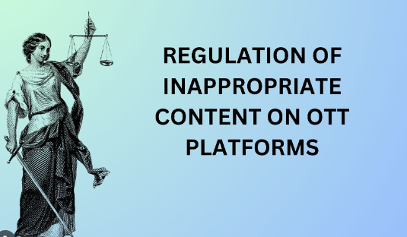

#### **2: Overview of Laws Related to Inappropriate Content**

1. **IT Act (2000) – Section 66A**:
   * A law in India (though struck down in 2015) that dealt with offensive online messages. It penalized sending messages that were deemed offensive or harmful.
2. **Section 69A of the IT Act**:
   * Allows the government to block access to any information that is deemed inappropriate or threatening to national security or public order.
3. **Defamation Laws**:
   * Posting false information that harms someone's reputation can lead to legal action for **defamation**. Laws differ by country, but penalties can include **fines** or **imprisonment**.
4. **Child Pornography Laws**:
   * Sharing or posting explicit content involving minors is illegal worldwide, with strict penalties including **jail time**.
5. **Copyright Infringement**:
   * Uploading or sharing content that violates someone’s copyright without permission can result in legal consequences, including heavy fines.

#### **3: Legal Consequences of Posting Inappropriate Content**

* **Fines**: Violating content policies or laws can result in **financial penalties**.
* **Imprisonment**: Certain offenses, such as child pornography, hate speech, and threats, can lead to **jail time**.
* **Permanent Ban from Platforms**: Platforms can ban users permanently if they violate their content policies repeatedly.
* **Criminal Record**: Depending on the severity of the offense, violators may face a **criminal record** that can affect future job opportunities or travel.

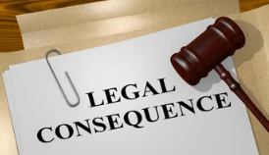

#### **4: Case Study 1 – PewDiePie’s Anti-Semitic Controversy (2017)**

* **Overview**:
  + PewDiePie, a popular YouTuber, made a controversial video with anti-Semitic jokes.
  + While he apologized, the backlash led Disney to cancel its partnership with him, and YouTube demonetized some of his content.
* **Legal Consequences**:
  + Though not a legal case, it demonstrates how inappropriate content can lead to **loss of partnerships, income**, and a damaged reputation.
* **Lesson**:
  + Even jokes or statements intended for humor can lead to severe backlash if they offend groups or violate policies.

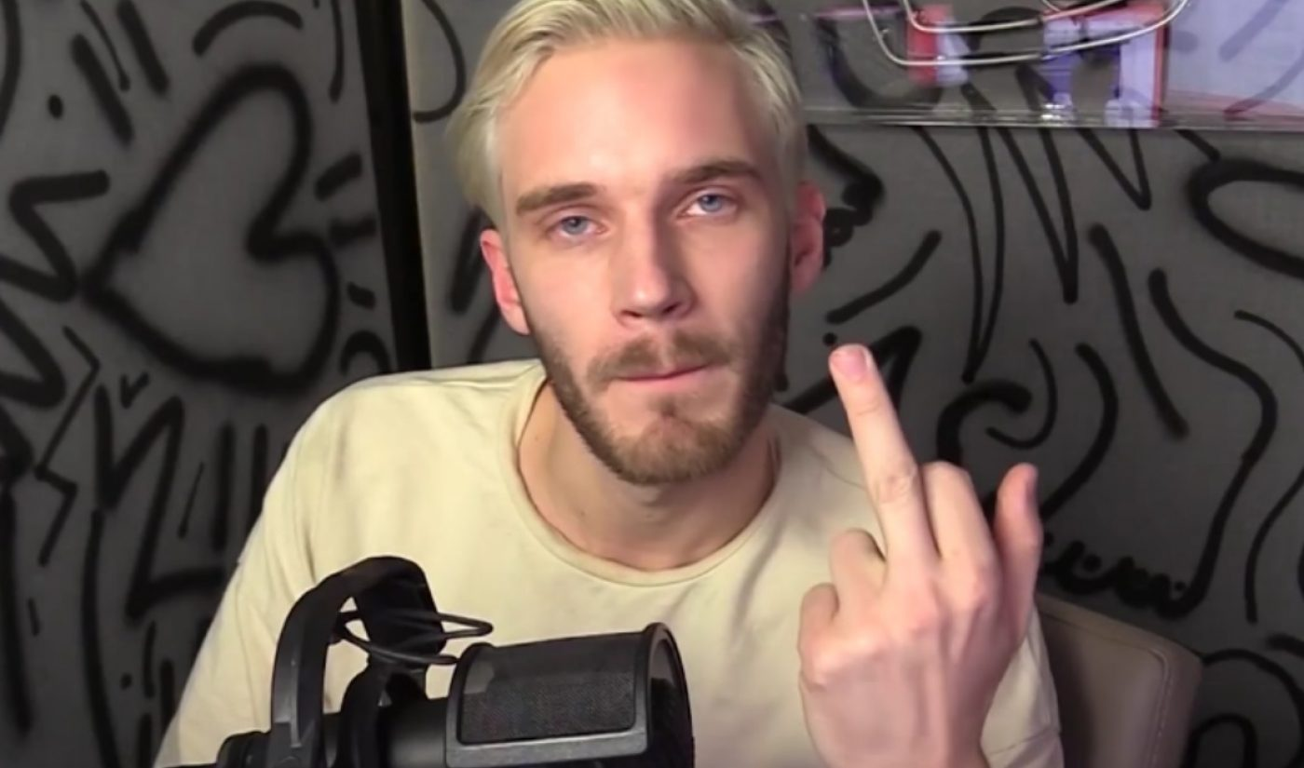

#### **5: Case Study 2 – TikTok Ban in India (2020)**

* **Overview**:
  + In June 2020, India banned TikTok and 59 other Chinese apps due to concerns over national security and inappropriate content.
  + The ban affected millions of users in India and was part of a larger move to regulate online content.
* **Legal Implications**:
  + The Indian government cited **Section 69A** of the IT Act to block these apps, claiming they posed a threat to national security.
  + Companies were required to comply immediately or face legal action.
* **Lesson**:
  + Governments can take broad action to regulate platforms if content is seen as harmful or violates national interests.



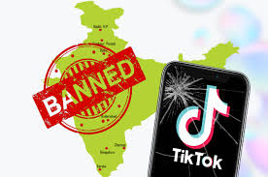

#### **6: Case Study 3 – Trump’s Twitter Ban (2021)**

* **Overview**:
  + After the U.S. Capitol riot on January 6, 2021, former President **Donald Trump** was permanently banned from Twitter for inciting violence through his posts.
* **Legal Consequences**:
  + No legal action was taken against Trump, but the social media platform acted under its **content policies** on hate speech and violence.
* **Lesson**:
  + Even high-profile individuals are not exempt from the consequences of inappropriate posts. Platforms can take drastic action to prevent misuse.

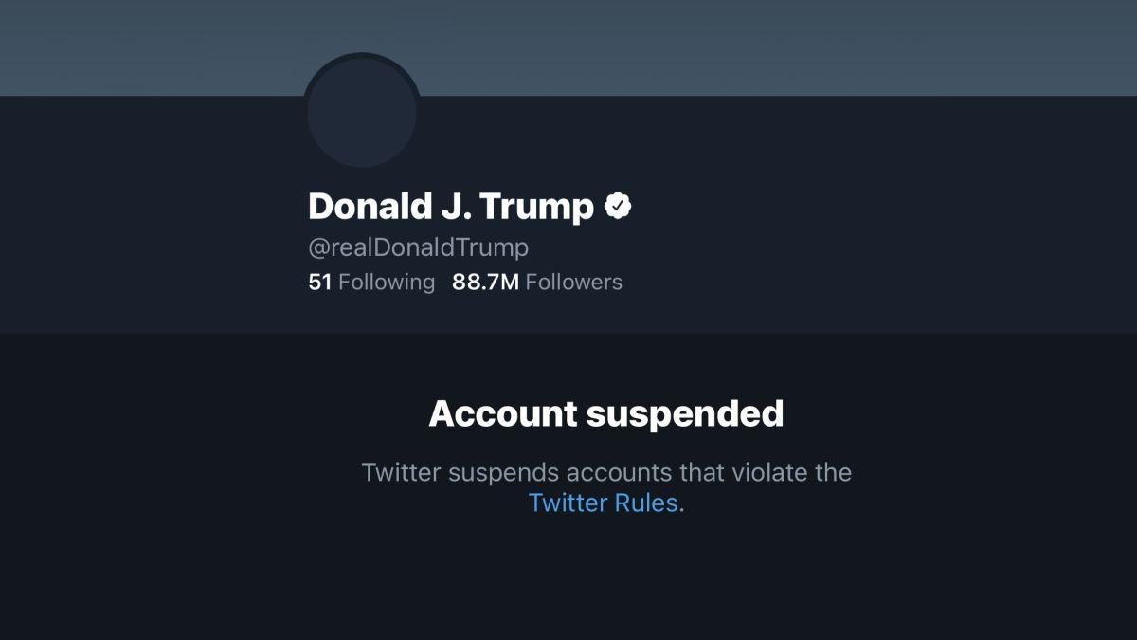

#### **7: Recent Example – The Spread of COVID-19 Misinformation**

* **Overview**:
  + In 2020 and 2021, social media was flooded with false information about COVID-19 cures, treatments, and conspiracy theories.
  + Posts that promoted false treatments or undermined public health efforts were flagged and removed by platforms like Facebook, YouTube, and Twitter.
  + Fake vaccines in rural areas
* **Legal Consequences**:
  + Some users faced **fines** for spreading false medical information, especially in countries where sharing such content violated public health laws.
  + For instance, **Brazil** fined social media users for sharing misinformation that put public health at risk.
* **Lesson**:
  + Posting harmful misinformation, especially during global crises, can result in legal action.

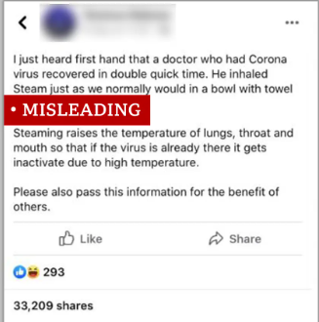

#### **8: Best Practices for Posting Online**

* **Think Before You Post**: Always consider if the content you’re posting could be harmful or offensive.
* **Verify Sources**: Ensure that any information you share is accurate and from reliable sources, especially when it comes to health or politics.
* **Respect Privacy**: Never share personal information about others without consent.
* **Avoid Hate Speech and Bullying**: Be mindful of your language and avoid anything that could be considered hate speech, harassment, or bullying.

#### **9: How Social Media Platforms Enforce Content Policies**

* **Automated Moderation**:
  + Platforms use AI and machine learning to automatically detect inappropriate content such as **hate speech** or **graphic images**.
* **User Reporting**:
  + Most platforms allow users to **report inappropriate content**, which is then reviewed by the platform’s moderation team.
* **Content Removal and Bans**:
  + Repeated violations can lead to **content removal**, **temporary suspensions**, or even **permanent bans** from platforms.

#### **10: Government Role in Regulating Online Content**

* **Laws for Protecting Citizens**:
  + Governments enforce laws like the **GDPR** (General Data Protection Regulation) in Europe to protect users from privacy violations.
  + India is working on its **Personal Data Protection Bill** to ensure users’ data is not misused by social media companies.
* **Blocking Harmful Content**:
  + Governments can use their legal powers, like **Section 69A of India’s IT Act**, to block apps or websites that share harmful content.

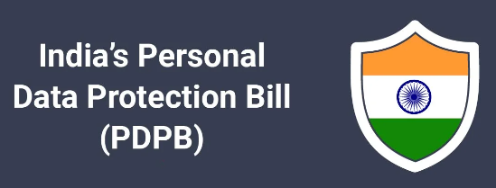

#### **11: Example of Early Incident –** [**Yahoo Chat Rooms (1999-2000)**](http://chatonline.chatkaro.in//)

* **Overview**:
  + In the early days of the internet, **Yahoo Chat Rooms** were popular for communication. However, they became a hub for **inappropriate and illegal content**, including discussions on illegal activities.
* **Legal Consequences**:
  + Several chat rooms were shut down, and legal actions were taken against individuals for **spreading hate speech** and **illegal content**.
* **Lesson**:
  + Even in the early days, inappropriate content online was met with legal action, showing how governments have always intervened in cases of misuse.

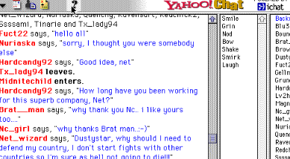

#### **12: Recent Case – Instagram's Crackdown on Cyberbullying (2022)**

* **Overview**:
  + Instagram launched a crackdown on **cyberbullying** and **harassment**, using AI to detect harmful posts and messages.
  + In 2022, the platform rolled out **new tools** to automatically flag messages containing threatening language.
* **Legal Consequences**:
  + Several countries, including the UK, have introduced **online safety laws** where platforms must take responsibility for user safety, or face fines.
* **Lesson**:
  + Social media companies now face **legal obligations** to protect users from harassment, and failure to do so can result in penalties.

#### **13: The Role of Governments in Social Media Privacy**

* **Governments Worldwide**:  
  Governments are implementing stronger data privacy laws to protect users from privacy breaches and misuse of personal data.
  + **General Data Protection Regulation (GDPR)**: Introduced by the European Union, it requires companies to be transparent about how they collect and use data.
  + **India’s Personal Data Protection Bill**: A proposed bill aiming to protect Indian citizens from social media misuse and ensure their personal data is secure.

#### **14: The Future of Social Media Privacy**

* **AI and Privacy**:
  + Platforms are increasingly using **artificial intelligence** to detect suspicious activities and protect users' data from potential threats.
* **Blockchain for Data Privacy**:
  + Blockchain technology is being explored to **secure personal data** on social networks, making data more transparent and secure.

#### **15: Group Activity – Social Media Privacy Audit**

* **Instructions**:
  + Review your privacy settings on platforms like WhatsApp, Instagram, Snapchat, and others.
  + Check for potential weaknesses, such as location sharing, public posts, or third-party app permissions.
  + Adjust settings to **strengthen privacy**, such as turning off GPS when not needed and limiting who can see your content.

This content provides a 1-hour lecture on **laws regarding inappropriate content**. By using real-life examples, case studies, and clear explanations of legal frameworks, students can better understand the **legal risks** and **responsibilities** associated with posting online.

### **Laws Related to Inappropriate Content in Detail**

#### **1. IT Act (2000) – Section 66A**

* **Purpose**:  
  Section 66A of the Information Technology Act (2000) in India was introduced to regulate offensive online messages. It focused on punishing people who sent information that was deemed offensive, false, or threatening through electronic communication.
* **Provisions**:  
  It penalized anyone who sent messages that could:
  + Cause **annoyance**, **inconvenience**, or **danger**.
  + Be known to be **false** but intended to cause harm.
  + Be **grossly offensive** or have a **menacing character**.
  + Be sent with the purpose of **causing insult** or **injury**.
* **Penalties**:  
  Violators could face up to **3 years of imprisonment** along with fines.
* **Why It Was Struck Down**:  
  In 2015, the **Supreme Court of India** struck down Section 66A because it was **too vague** and could be easily misused. People were being arrested for social media posts that were merely critical of politicians or other public figures, leading to concerns about **freedom of speech**.  
  The court ruled that the section violated the **right to freedom of speech and expression** under **Article 19(1)(a)** of the Indian Constitution.

#### **2. Section 69A of the IT Act**

* **Purpose**:  
  Section 69A empowers the Indian government to **block public access** to any online information that may pose a threat to **national security** or **public order**.
* **Provisions**:  
  The government can direct any agency or intermediary (e.g., social media platforms, ISPs) to block access to specific content under the following conditions:
  + When content is seen as **threatening India’s sovereignty and integrity**.
  + When it can **affect friendly relations with other countries**.
  + When it may **endanger public order** or **incite the commission of an offense**.
* **Notable Example**:  
  Section 69A was invoked during the **TikTok ban** in India in 2020, along with 58 other Chinese apps, due to concerns over national security and data privacy. The government felt that the apps posed risks, particularly during geopolitical tensions with China.
* **Penalties for Non-Compliance**:  
  Any intermediary or service provider who fails to comply with blocking orders under Section 69A can face **imprisonment of up to 7 years** and **fines**.

#### **3. Defamation Laws**

* **What is Defamation?**:  
  Defamation occurs when someone spreads **false information** that harms another person’s **reputation**. It can take two forms:
  + **Libel** (written defamation).
  + **Slander** (spoken defamation).
* **Key Provisions (India)**:
  + Defamation is covered under **Section 499** and **Section 500** of the Indian Penal Code (IPC).
  + **Section 499** defines defamation as any statement that could **lower a person’s reputation** in the eyes of others.
  + **Section 500** prescribes the punishment for defamation, which can include **up to 2 years of imprisonment**, a **fine**, or both.
* **Civil and Criminal Defamation**:
  + **Civil defamation**: The victim can seek compensation for the damage to their reputation through a lawsuit.
  + **Criminal defamation**: The accused can be imprisoned or fined for causing harm to someone’s reputation.
* **Real-Life Example**:  
  In 2016, **Arvind Kejriwal**, the Chief Minister of Delhi, faced a **criminal defamation lawsuit** filed by Finance Minister **Arun Jaitley**. Kejriwal had accused Jaitley of corruption, and the latter sought legal action to protect his reputation.
* **Implications for Social Media**:  
  Posting false or misleading information about someone, especially public figures, can result in legal action. Many celebrities and politicians have filed defamation cases due to social media posts that damaged their reputations.

#### **4. Child Pornography Laws**

* **Purpose**:  
  **Child pornography** refers to any material (images, videos, etc.) that depicts **minors in sexually explicit situations**. It is **illegal worldwide**, and many countries have very strict laws against it.
* **Provisions (India)**:  
  The **Protection of Children from Sexual Offenses (POCSO) Act** and **IT Act, Section 67B** are used to address child pornography in India.
  + **Section 67B of the IT Act** criminalizes the **publishing, transmitting, or viewing** of child pornographic material in any form.
  + **POCSO Act**: Designed to protect children from sexual abuse, it also includes penalties for creating, sharing, or possessing sexually explicit images of minors.
* **Penalties**:
  + The punishment for offenses related to child pornography under Section 67B can be **5 to 7 years of imprisonment**, along with heavy fines.
  + The **POCSO Act** can also impose **lifetime imprisonment** in severe cases.
* **Global Example**:  
  In 2019, **Jeffrey Epstein**, a wealthy financier, was arrested for operating a **child sex trafficking ring**. His actions involved the abuse and exploitation of minors, and the case gained global attention for highlighting the pervasive problem of child abuse.
* **Recent Incident**:  
  In 2021, authorities in the **UK** uncovered a massive child pornography network using **encrypted messaging apps**. Several arrests were made, and those involved are facing significant jail time for sharing and distributing explicit content involving minors.

#### **5. Copyright Infringement**

* **What is Copyright Infringement?**:  
  Copyright infringement occurs when someone uses or distributes **creative work** (books, music, films, software, etc.) without the **creator’s permission**.
* **Copyright Act in India (1957)**:  
  India’s **Copyright Act, 1957** grants protection to original works such as literary, dramatic, musical, artistic, and cinematographic creations. It ensures that only the **author** or **owner** of the work has the right to:
  + **Reproduce** the work.
  + **Distribute** copies of the work.
  + **Perform** or **display** the work publicly.
* **Penalties**:
  + **First-time violators** may face up to **6 months of imprisonment** and/or **fines** between INR 50,000 to 2,00,000.
  + Repeat offenders may face up to **3 years in prison** and fines of up to INR 2,00,000.
* **Real-Life Example**:  
  In 2013, the **movie industry** in India took legal action against several websites for illegally hosting and distributing films without permission. The government blocked many of these sites under copyright laws.
* **Implications for Social Media**:  
  Uploading content that you do not own, such as copyrighted songs or movies, can result in **take-down notices**, **fines**, or even **legal prosecution**. Platforms like YouTube and Instagram have implemented strict copyright detection systems to avoid such issues.